**COMSATS UNIVERSITY ISLAMABAD,**

**ABBOTTABAD CAMPUS**

**Computer Networks**

**ASSIGNMENT # 1**

**Submitted to: Mukhtiar Zamin**

**Submitted by: Muhammad Umer Liaqat**

**Reg No: FA22-BSE-053.**

**Brief Introduction to Case Study**

The university portal application enables instructors to manage various aspects of course administration. It offers four primary functionalities: taking attendance, setting assignments, uploading course content, and setting quizzes.

For this case study, the focus is on the **Attendance Taking** functionality. In this functionality, the instructor can take attendance by selecting the date, viewing a list of students, and marking each student as "Present" or "Absent." Once completed, the attendance is saved, providing a record of each student's attendance status for that date.

The **Attendance Taking** functionality showcases how instructors can efficiently manage and record student attendance, supporting both educational objectives and streamlined course management.

**USE CASE DIAGRAM**

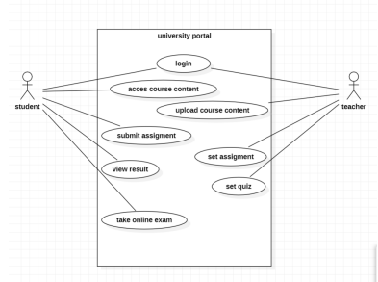

**SSD of Use Case**

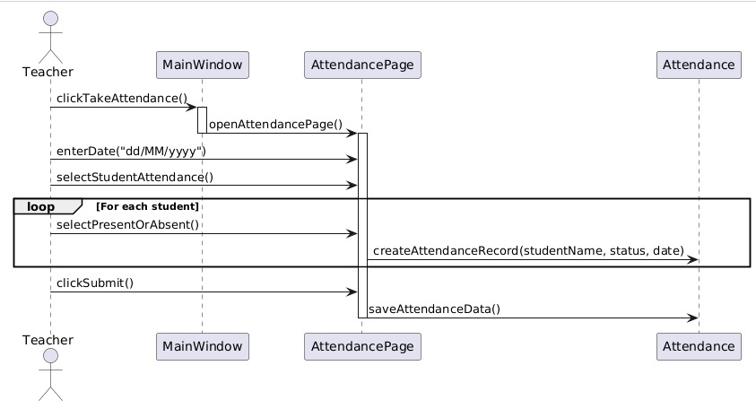

**Communication Diagram**

**Class Diagram**

**Package Diagram**

